**C O U R S E O V E R V I E W**

English II Honors

Mrs . Proctor

**H O W T O C O N T A C T T H E T E A C H E R**

**Email:** proctol2 @ gcsnc.c om

I will respond as soon as I possibly can or feel free to leave a message in the office.

**W H A T Y O U N E E D F O R C L A S S**

# Required Supplies:

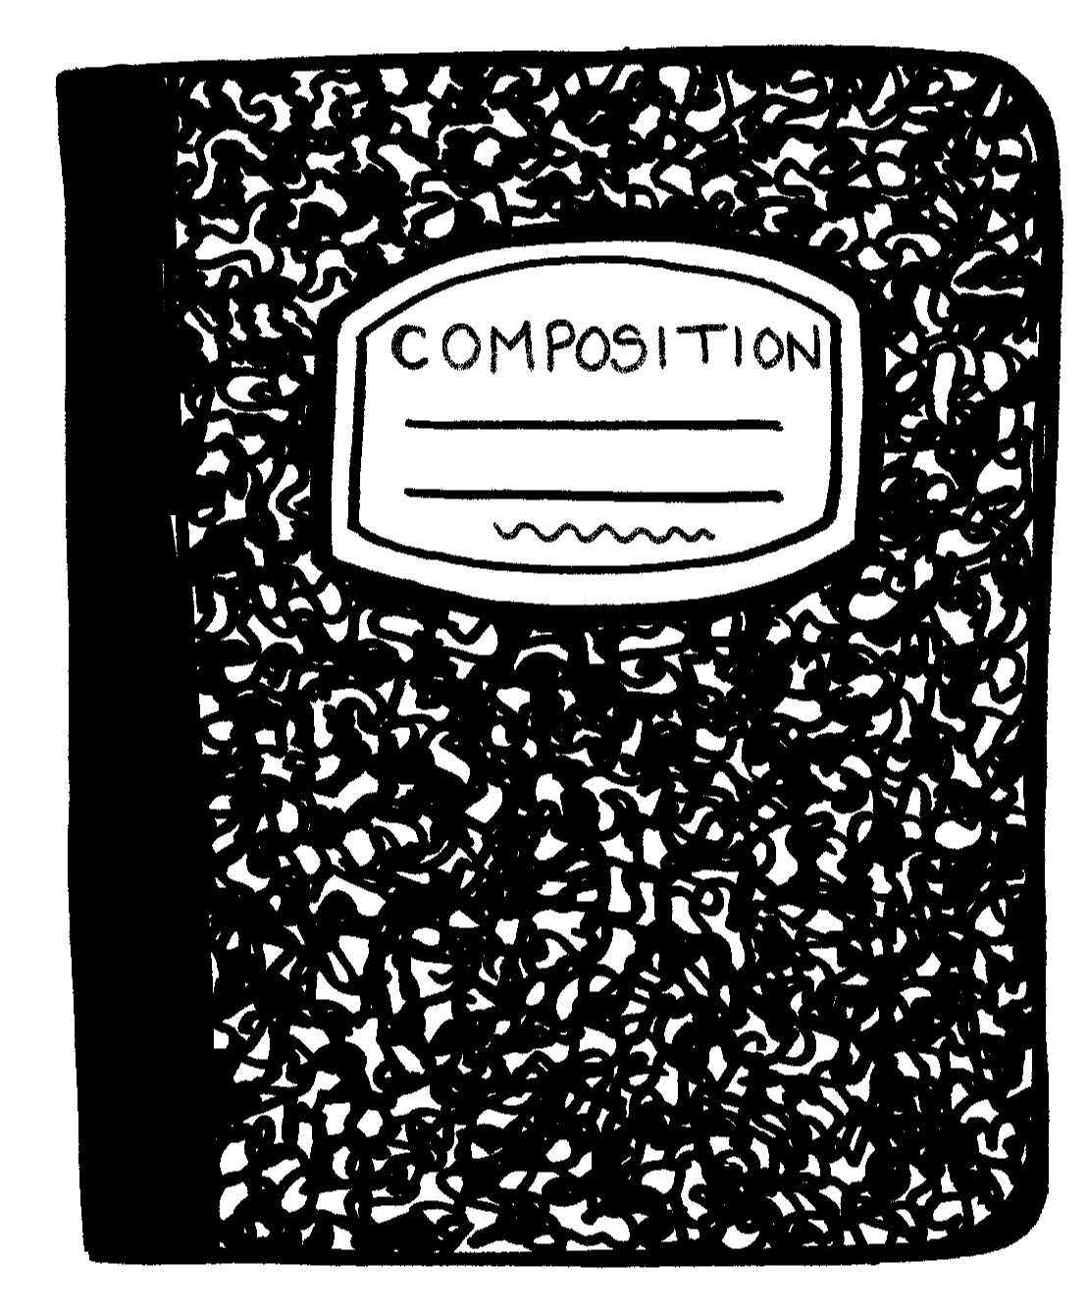Chromebook ( and charger) Notebook

Pen or Pencil

This course will help students develop the English

language skills they will need to become productive

members of our ever-changing world. In each unit,

students will be exposed to a variety of different

types of l i terature such as novels, short stories, memoirs, poems, speeches, and non- f iction

informational text. Students will not only read and

learn to analyze texts but will a lso practice writing, speaking and l istening based on grade- level State

Standards.

**C L A S S R O O M R U L E S**

1. Be kind- treat everyone the way you want to be treated and think before you speak.
2. Be responsible- do what you are supposed to do when you are supposed to do i t .
3. Be respectful- respect yourself, your teachers, your peers, and your environment!

**C E L L P H O N E P O L I C Y**

The school cell phone policy will be followed. All electronic devices will be inaccessible for the duration of the period.

**G R A D I N G S C A L E A N D I N F O R M A T I O N**

# Q u a r t e r l y G r a d e s F i n a l G r a d e s

**Recommended Supplies:**

Highlighters

Glue Stick or Tape Index Cards

**All of these are available in the classroom, but it can be helpful to have your own supply!**

Warmups and Participation: 30% Tests, Essays, and Projects: 30%

Classwork: 30%

1st Quarter Grade: 40% 2nd Quarter Grade: 40%

Guilford County Schools Final

Exam (GCSFE): 20%

Colorful Markers, Pens, or Colored Pencils

**L A T E W O R K P O L I C Y**

Vocabulary: 10% Units of Study: short stories, *Lord of the Flies*,

*Macbeth*, vocabulary, grammar and writing

**L E A R N I N G H U B**

Learning Hubs are held Tuesday/ Thursday afternoons

(4 : 20 pm- 6 : 00 pm). Hub is the best

way to get help on your work, catch up on missing assignments, or to

have a quiet place to work!

Late work will be accepted with a 10% deduction at teacher' s discretion. I f students need an

extension on an assignment to avoid a late penalty they should communicate that need with me.